Guided by Christ-Partners in Mission-Excellence in Education
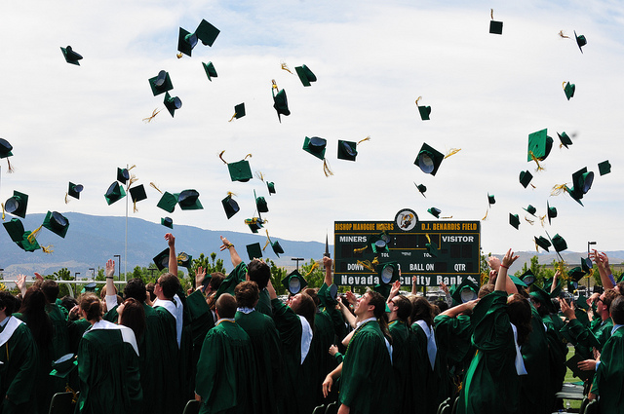
Diocese of Reno Scholarship (D.O.R.S.) Annual Report 2015-2016
History:  Established in 2010, the Diocesan Scholarship was the joint vision of Bishop Emeritus Philip Straling and Bishop Randolph Calvo. Initially funded by an anonymous $100,000 donation and matched by the Diocese of Reno, these scholarships provide access to Catholic education to students most in need. In 2011-2012 this same donor offered a $50,000 matching contribution, and donors nearly met this challenge, raising an additional $42,000. For the year 2013, we raised $ 100,000.00 and the same anonymous donor matched that amount! In 2014, we raised over $44,000.00 which was again matched!  In Spring 2014, the National Catholic Education Association, (NCEA) recognized the Diocese of Reno for our success by naming us the recipient of the Catherine T. McNamee, CSJ Award for “Outstanding Leadership in Promoting a Vision of Catholic Education that Welcomes and Serves Cultural and Economic Diversity and Enhances Services for Students with Special Needs.”  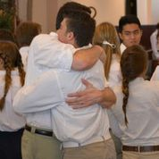  Statement of Account:  We are proud to report that 100% of proceeds are applied to the scholarship.  Total Fund Balance: July 1, 2015 $ 493,933.66  The need is great!  A third party organization, FACTS Grant and Aid reviews need.  Year Number of students applying for tuition assistance FACTS Calculated need Number of D.O.R.S. recipients  2011-2012 381 $827,644 12  2012-2013 346 $947,543 16  2013-2014 342 $871,173 21  2014-2015 362 $1,205,689 29  2015-2016 355 $1,248,240 33  Financial Benefits and Criteria:  Schools receive $2,000 per year per student for the duration of the students’ education in a Diocese of Reno Catholic school. Grade and citizenship requirements have been established, as have been requirements for parental involvement through both service and financial support. Students attending Bishop Manogue Catholic High School, St. Teresa of Avila School (Carson City), Little Flower School, Our Lady of the Snows School, and St. Albert the Great are recipients. | Efforts to Increase fund:  - Annual appeal letter  - D.O.R.S. website  - Imagination Graduation June 2015  - Parish Presentations  - Bulletin announcements  - Announcements on Immaculate Heart Radio  - Notices on the Diocesan website  - Outreach at the Diocesan conference  - Third annual D.O.R.S. Concert on September 26, 2015 featuring choirs from all schools, as well as dinner by the Miner Diner!  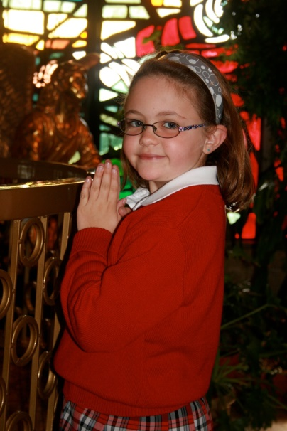
Members of the Diocese of Reno Scholarship (D.O.R.S.) committee:  John Anxo, M.D., President, Diocese of Reno School Board Karen Barreras, M.Ed., Superintendent of Catholic Schools  Jim Carrico, Finance Chair, Diocese of Reno School Board  Jim Cavilia, Esq., Diocese of Reno School Board  Randy Pane, DDS, Vice President, Diocese of Reno School Board  Jim Toner, Past President, Bishop Manogue Catholic High School  For more information, call (775) 326-9430, or email karenb@catholicreno.org or www.catholicrenoscholarship.org 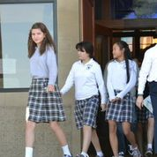 | Our educational success is excellent!  BMCHS Graduation Rate is 100%, with 99% going to college, universities or the military.  Recent ACT/Aspire scores for grades 3-8 exceeded national scores.  Gratitude from students and parents:  From parents: I want to truly thank you for the blessing of your gracious gift.  You have made a big difference in our son’s life and future and we owe a huge debt of gratitude to D.O.R.S.  (Our son) has always thrived. I feel it is because of the excellent faith based education he receives and the stable environment of the school.  From recipients: Thank you for making it possible for me to go to Catholic school. I know I will succeed in life with the guidelines and teachings I am learning.  I like how we learn about God. I’ve learned tons from this school. It’s the best! I like to go to Church every week.  When my mom told me that I got a scholarship, I was just so excited. I also get excited whenever there’s a D.O.R.S. concert. I really like singing at the concert every year. Once again, thank you and God bless.
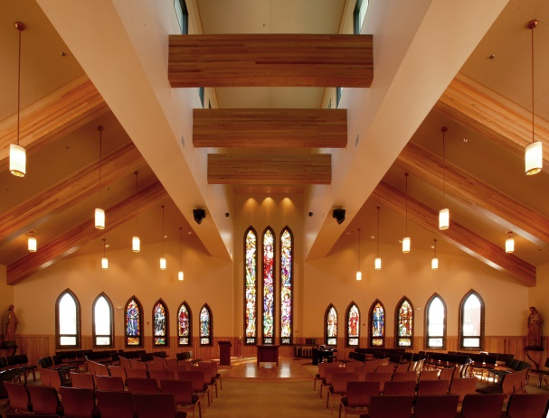  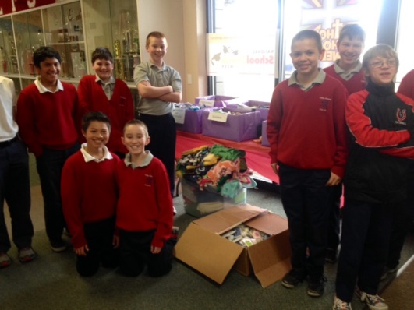 | 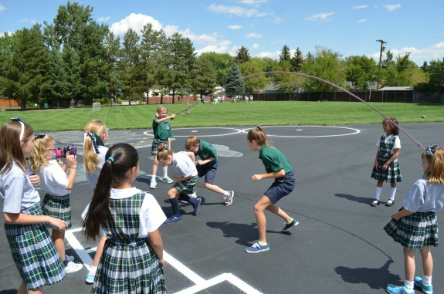  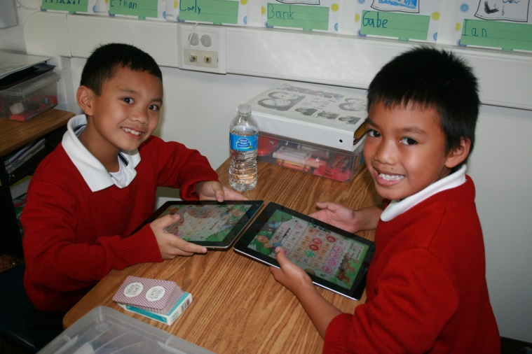

“Not just a book or paper or pencil, Open the doors to the children of God…Jesus our Savior was clear as can be, ‘Let the children come to me,’” in To the Children of God CD by Joseph deRosa

